Marketing Update

- Monthly Webinar: Seniorly – I figured since I have been promoting it for several weeks, why not host a webinar with them. Many of your fellow franchisees are using Seniorly and making money. Seniorly connects senior housing operators, in-home care agencies, and placement agencies with qualified leads and provides software to effectively manage senior care transitions. Please click here to register: https://register.gotowebinar.com/register/6628973596738275596

- Quarterly SEO Report – The second quarter SEO report has been posted to the marketing website. Please click here to view: https://myabcmarketing.com/marketing-hub/

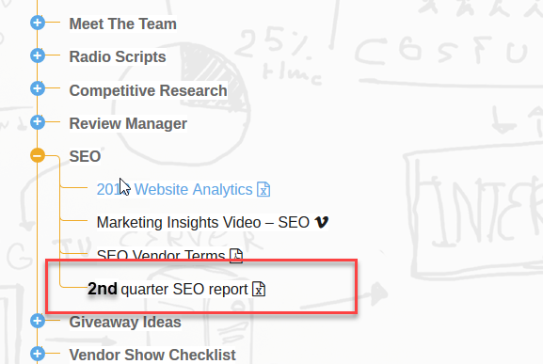

- Second Quarter NAF Reports – The goal is to get everyone their second quarter NAF reports in the coming week. Everyone should be proud of themselves as I can see lots of improvement quarter over quarter. Keep an eye out for it and as always if you have any questions or need assistance, please let us know.

- Alzheimer’s Campaign – I was just speaking to our contact at the Alzheimer’s Association and she mentioned a bill stuffer has been working pretty good as a fundraising vehicle. I realize many of you might not be physically mailing out invoices, so please consider adding a postcard graphic to your email. Click here to see our postcard graphic that can be converted to a customized image that you can use for your efforts. Please put a request in through the print store if you are interested.

