Marketing Update

- Marketing Webinar – Caregiving recruiting and retention tactics using BombBomb. A few months ago we introduced BombBomb to the system. This webinar will demonstrate how our very own Always Best Care franchisee, Steve Snell, is using BombBomb with proven success. With caregiver recruitment being one of the most challenging obstacles to contend with, Steve has figured out how to use this technology to increase his success rate on both recruitment and retention. This is a must watch webinar if you are having caregiver recruitment and retention challenges.
Please register for this webinar scheduled on September 19, 2019, at 9:00 AM PST. Click here or the link below:
https://attendee.gotowebinar.com/register/3789949912219900173

- Pet Adoption Campaign Deadline is Coming up – Looking for some positive PR in your community, then why not consider doing the pet adoption campaign. Click here to see the overview or feel free to go to the marketing channel to view a past webinar on this concept. The NAF will fund a PR campaign and $500 credit towards your efforts. There has not been one market since we stated this campaign who has not received PR from this campaign. As a matter of fact, some markets have flourished with the amount of PR they have received. And, the other positive is that the pet adoption is something you can post on social media, put in your brag book, talk about with your referrals and a differentiator from your competitors. If you are interested, I need a confirmation sent directly to me so I can get you connected with our PR team.

- NAF Advertising Co-op Deadline is September 27th – Don’t forget to turn in your NAF co-op receipts to me before September 27th. I will approve them, then send them to Zeny to process. Zeny will EFT you the reimbursement in October. This applies for the advertising co-op, signage co-op, car wrap co-op, SendOut card co-op and the special NAF incentive co-op. Click here for the advertising co-op guidelines.

- E-mail Signature – As you bring new staff into your office, it’s important to remember everyone’s e-mail signature should be to brand standards. I have seen a few non-branded e-mail signatures lately, so I just wanted to give you a reminder. Please remember, we want consistency in everything we do. If you need advice on how to change your e-mail signature, please try downloading this document in the marketing hub. I think you will find the step by step instructions very helpful.
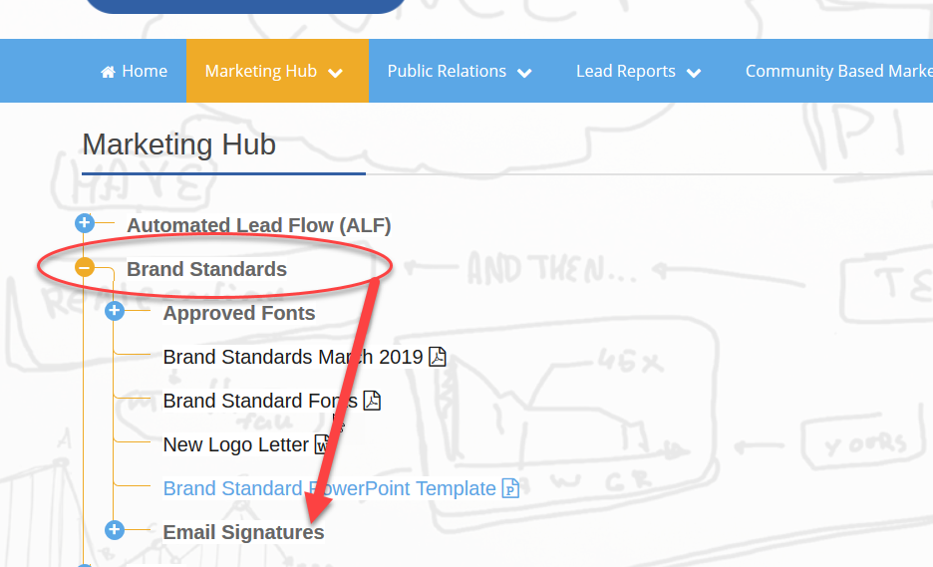

- Alzheimer’s Campaign – I was just speaking to our contact at the Alzheimer’s Association and she mentioned a bill stuffer has been working pretty good as a fundraising vehicle. I realize many of you might not be physically mailing out invoices, so please consider adding a postcard graphic to your email. Click here to see our postcard graphic that can be converted to a customized image that you can use for your efforts. Please put a request in through the print store if you are interested.

