Marketing Update

- New Print Store Launch – Today we officially launched the new print store at www.myabcprint.com. Click here to listen to the webinar recording: https://register.gotowebinar.com/recording/1679854061813809419. Your username is your Always Best Care e-mail address and the password is ABC2020. Hope you enjoy it.

- Need Hand Sanitizer? – NDS our preferred vendor has some available while supplies last. See the attachment called Hand Sanitizer for details

- Coronavirus Newsletter Template is Available on Emma – We know how important it is to communicate with your referral sources and clients. With that being said, a new coronavirus newsletter template has been made available in Emma. Please note, Tim Forrester can assist in sending out information on your behalf, but that information has to come from you. Tim will only place in the content you provide to him. Below is a view of the template.
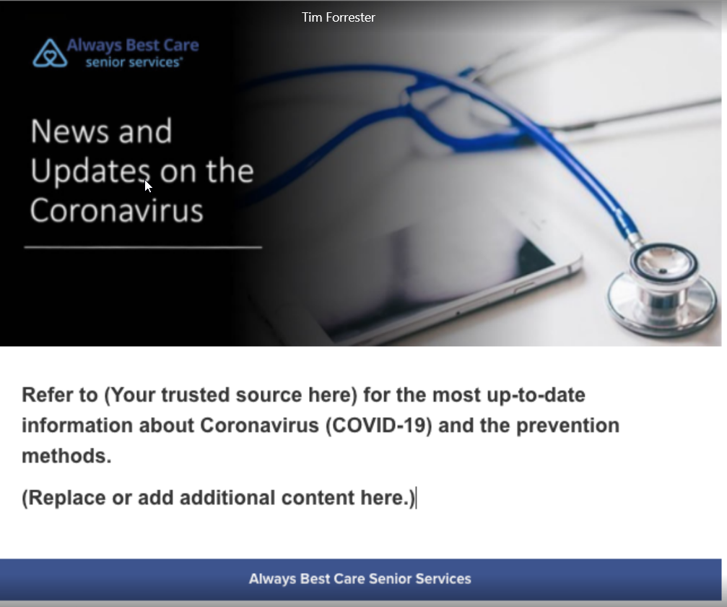

- New Recruiting Flyer is Available – With the misfortune of social distancing, many industries have reduced hours or suspended operations. This flyer speaks to that group of individuals that may be searching for a job to bring income into their household. See attached or click on this link: http://xbjae.vfyqk.servertrust.com/product-p/1f86.htm. It will be in the new print store shortly.

- New Balance Tracking System Stand Up Banner – Hot off the press is the Balance Tracking System stand up banner for public events. It can be found in the artwork library at http://xbjae.vfyqk.servertrust.com/product-p/1rb10.htm.

- Phillips Lifeline Newsletter – click here

- New Caregiver Portal – In conjunction with our ongoing Caregiver Centric campaign we are constantly looking for better ways to better communicate with your caregiver staff. We also believe going green is an important strategy we should all try to promote when possible. With that being said, the Caregiver Portal has been developed to help streamline all your internal contacts, policies, forms and training documents. It is an external website that is managed by Mr. Marketing our SEO vendor. See below for a glimpse into this portal:

Home Page:
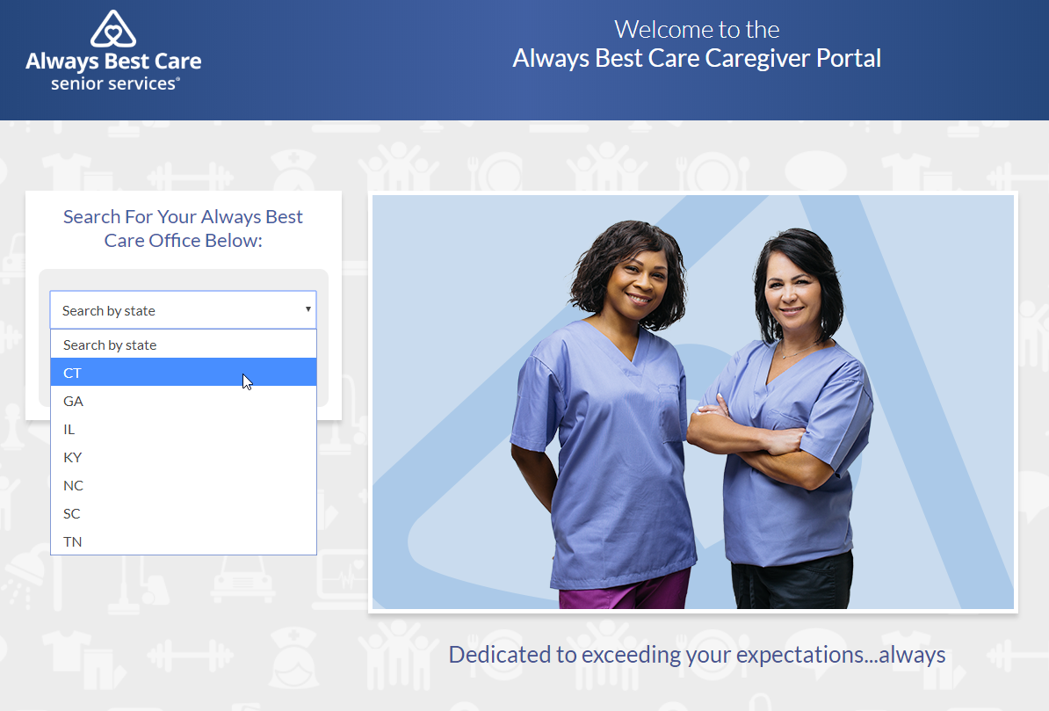

Select Your Office:
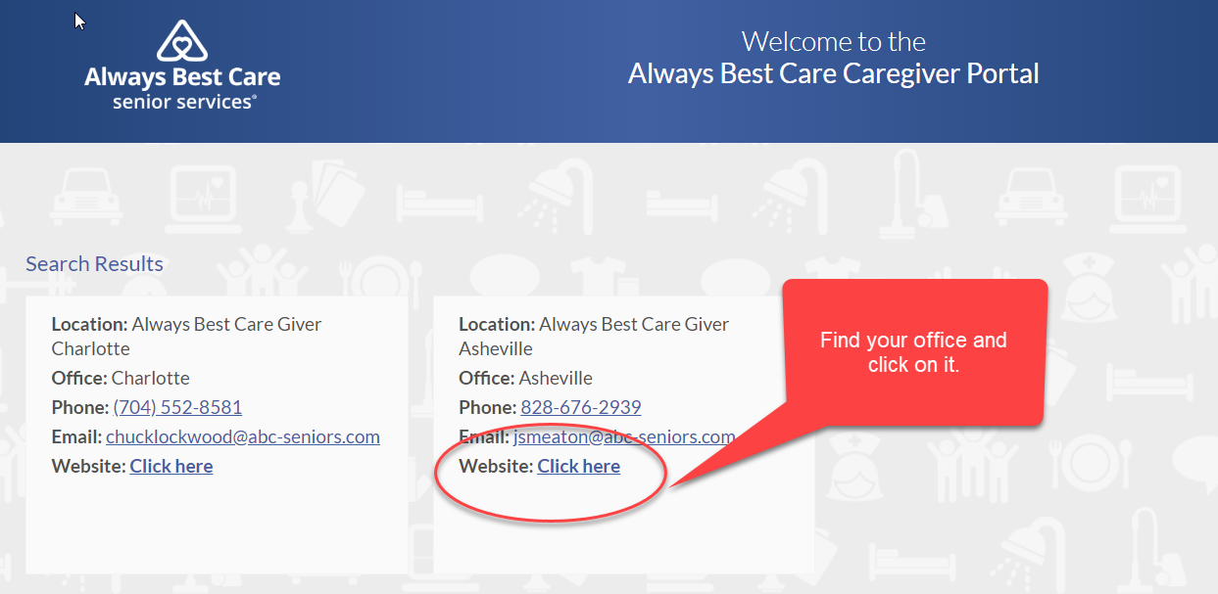

Customizable Content:
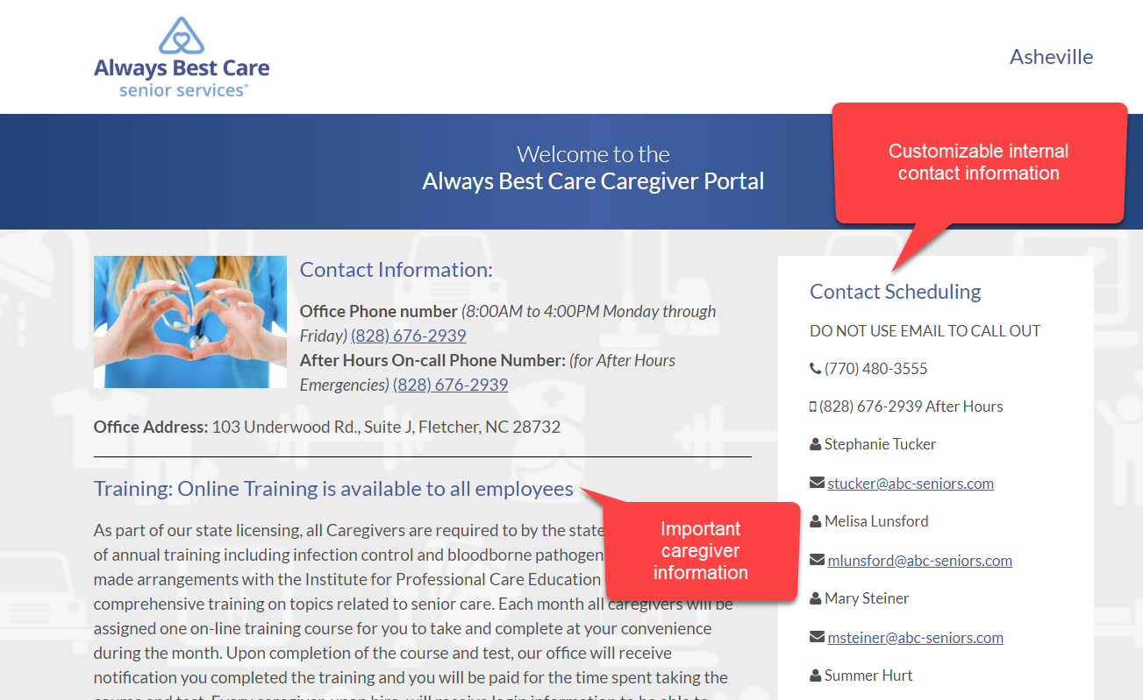

Add Important Downloadable Documents and Forms:
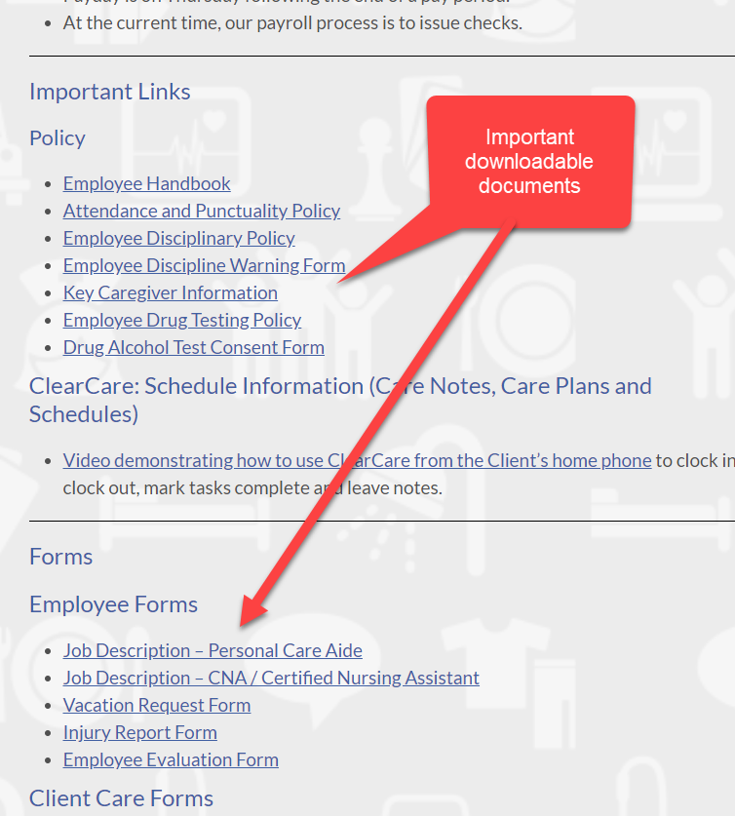

If you see what you like, the best thing is it is a one-time set up fee of $100. To make it sweeter, the NAF will accept your receipt and match your expense. So, the total fee will be only $50. Imagine how much time, paper and effort you can save by using this website. It is easy to set up with just a quick enrollment form provided by Mr. Marketing. To get started, please contact Carrie at (843) 410-1046. It will practically pay for itself after just a few months.

- Social Media E-mail Box – Send all social media local content to Cindy Steinberg at our new dedicated email box at socialmedia@abc-seniors.com.

