**Marketing Update**

1. **BombBomb Update –** The votes are in and we fell a little short of 45, but we got a special offer to make up for it. First of all, BombBomb has extended everyone’s account until June 15th. After June 15th, the corporate account will be shut off and everyone’s account will become inactive. Anyone who would like to renew their account will see this banner below the following time they log in. Once you click on the orange "re-subscribe" button, you will be able to sign up for your new annual account.

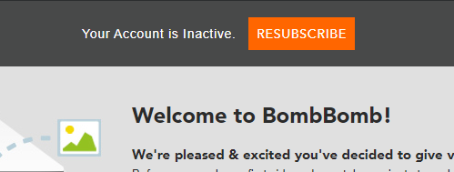

And, once you have signed up, don’t forget to e-mail me your receipt. So here is the special bonus offer, any franchisee that re-activates their BombBomb account within the first two workweeks after the accounts close, so by **Friday, June 26th**, will receive two FREE months of BombBomb at no cost. The two-month extension on your subscription is worth $78/account, which comes to close to the original discount we were trying to receive as a system last week. Lastly, remember this year we will co-op your NAF BombBomb reimbursement at 100%. Let me know if you have any questions.

1. **New Marketing Material –** For those willing to take COVID-19 cases, this marketing material is right up your alley. Please click on this link: <http://xbjae.vfyqk.servertrust.com/product-p/1f94.htm>
2. **Upcoming Marketing Webinar** – Please tune into this year’s Alzheimer webinar to get firsthand information from our contact at the Alzheimer’s Association how this year’s campaign will differ from years past. Please register for Launching Your Alzheimer’s Campaign 2020 on June 12, 2020 9:00 AM PDT at: <https://register.gotowebinar.com/register/5746836523832066830>
3. **Caregiver Centric Campaign** – Marketing’s ongoing Caregiver Centric campaign is on a roll again. Last week our agency delivered a nationwide press release on Always Best Care recruiting caregivers nationwide which delivered a few nice pick-ups by the media. Next week we are delivering a social media campaign using this creative below. And we already have other ideas waiting in the wings. We’re working hard in the marketing department to assist you in hiring more caregivers!!!!!



1. **Ongoing Server Maintenance** - We have one more week of server maintenance. Sorry for the inconvenience. We will be back online on June 1st.
2. **Quarterly NAF Reports** – This week I should be able to complete the quarterly NAF Tableau reports for your review. Please keep an eye out for them as they can help you determine how you are managing your leads vs. the systemwide average.
3. **New Caregiver Portal** – We are still taking orders for the caregiver portal. We went from 20% of our system signed up to 30% in no time. In conjunction with our ongoing Caregiver Centric campaign we are constantly looking for better ways to better communicate with your caregiver staff. The Caregiver Portal was developed to help streamline all your internal contacts, policies, forms and training documents and whatever you can dream of. It’s an external website that is managed by Mr. Marketing our SEO vendor. Please see below for a glimpse into this portal:

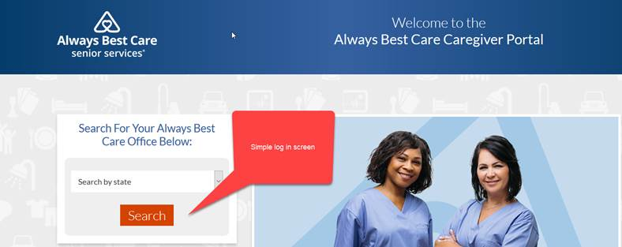

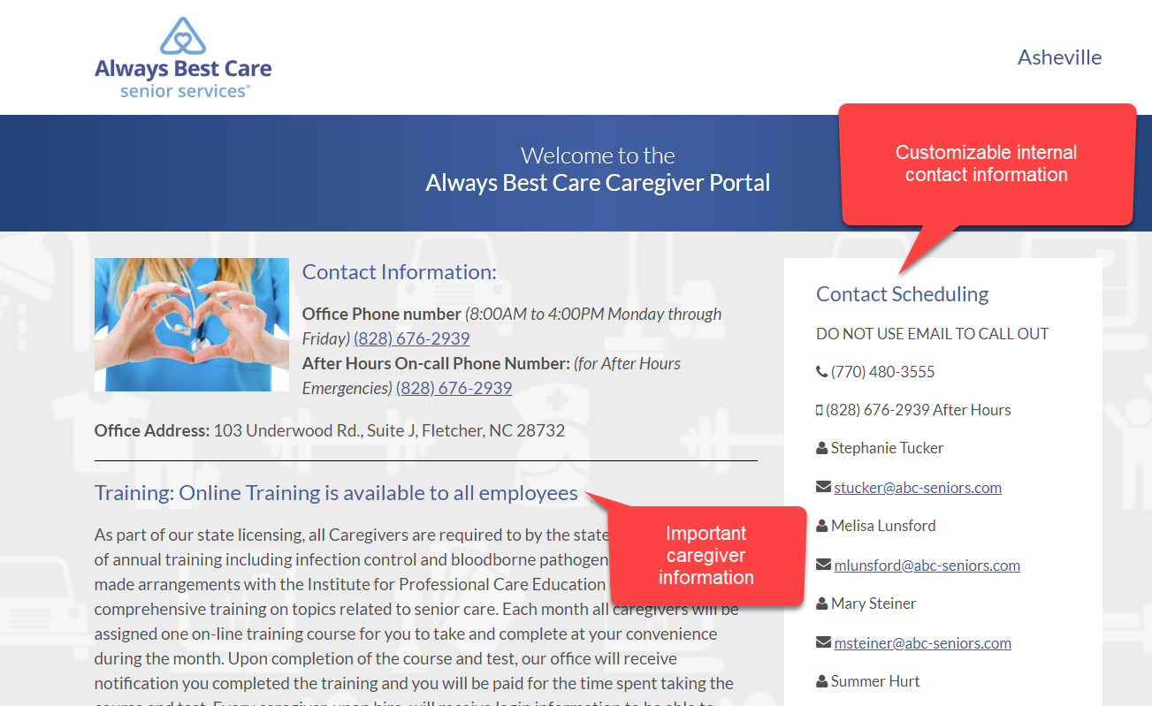

If you like what you see, the best thing is the one-time set up fee of only $100.  To make it sweeter, the NAF will accept your receipt as part of the NAF co-op.  So, the total fee will be only $50 out of pocket.  Imagine how much time, paper and effort you can save by using this website.  It will practically pay for itself after just a few months. To help you get started, please call me at (916) 596-1825, or we will give you a call in the near future to get started.  We will even help start the enrollment process on your behalf & submit it to Mr. Marketing.  We hope this caregiver initiative does wonders to streamline your process as well as saves you time & money.