**Marketing Update**

1. **Sign Up Today for the July 15th – Marketing Training Refresher Course –** As you may have seen over the course of my tenor, my platform has been very digital heavy focused. From day one, I rolled out a major SEO push, focused heavily on lead generation, e-mail marketing, social media marketing, reputation management. My refresher course is going to teach you the importance of each of these areas, how to incorporate them into your daily schedule and how they all work together. It is open to everyone wanting to get the latest marketing training.[**Click here to register**](https://register.gotowebinar.com/register/4528550152779702032)**:** <https://register.gotowebinar.com/register/4528550152779702032>
2. **Marketing Website Password Update** – Once a year we change our marketing website password to protect one of our most valuable resources from visitors that are not welcome. So, on July 1st we will make the official swap. The password will be changed to Marketing24-7!
3. **New Marketing Material –** This week we took a different direction. We added a client satisfaction survey as this is a very important aspect of marketing. Some have used Home Care Pulse and others have done it in-house. In any case if you haven’t done one, you really should. Please [click here](http://xbjae.vfyqk.servertrust.com/product-p/1f97.htm) to view it: <http://xbjae.vfyqk.servertrust.com/product-p/1f97.htm>
4. **New Caregiver Portal** – We are still taking orders for the caregiver portal. We went from 20% of our system signed up to 30% in no time. In conjunction with our ongoing Caregiver Centric campaign we are constantly looking for better ways to better communicate with your caregiver staff. The Caregiver Portal was developed to help streamline all your internal contacts, policies, forms and training documents and whatever you can dream of. It’s an external website that is managed by Mr. Marketing our SEO vendor. Please see below for a glimpse into this portal:

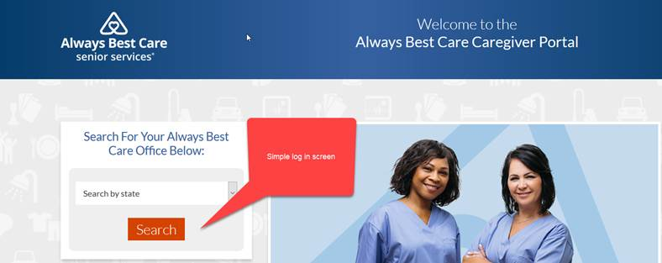

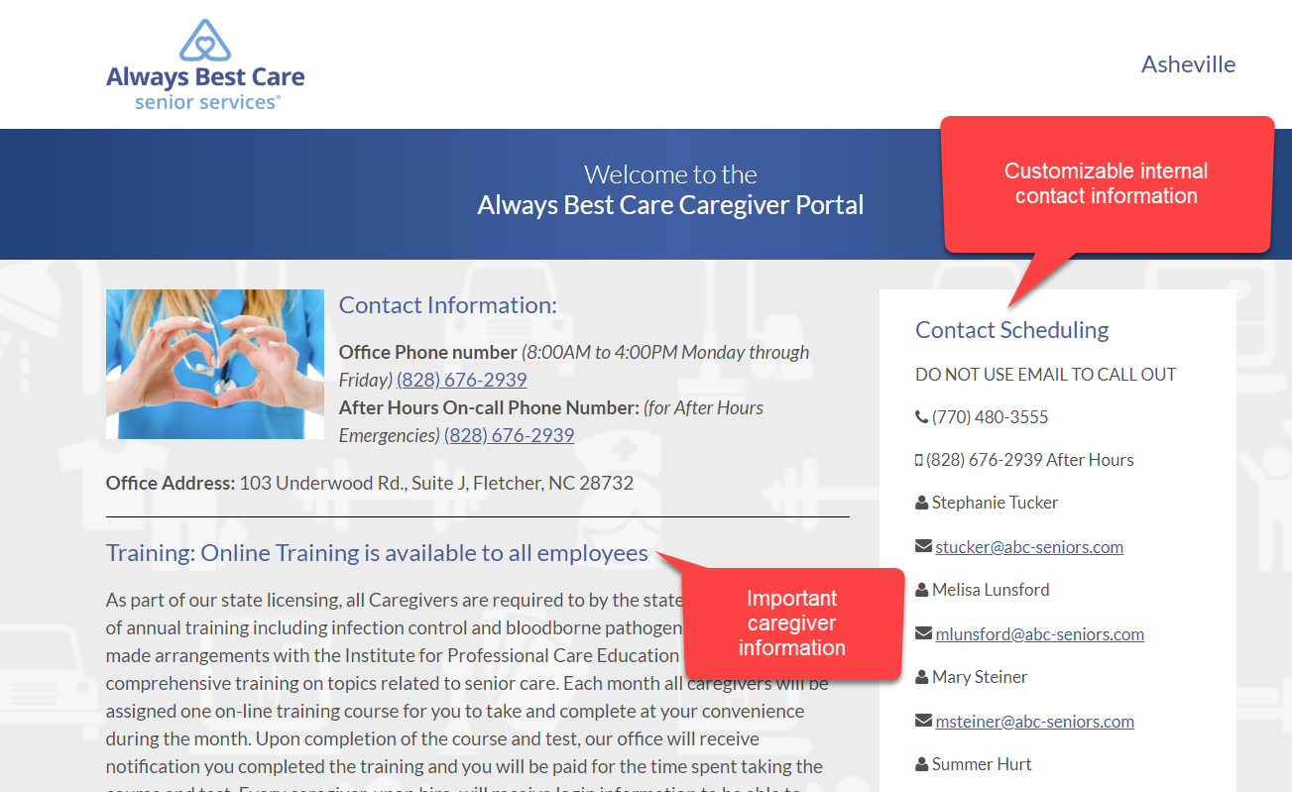

If you like what you see, the best thing is the one-time set up fee of only $100.  To make it sweeter, the NAF will accept your receipt as part of the NAF co-op.  So, the total fee will be only $50 out of pocket.  Imagine how much time, paper and effort you can save by using this website.  It will practically pay for itself after just a few months. To help you get started, please call me at (916) 596-1825, or we will give you a call in the near future to get started.  We will even help start the enrollment process on your behalf & submit it to Mr. Marketing.  We hope this caregiver initiative does wonders to streamline your process as well as saves you time & money.