**Marketing Update**

1. **Chatbot Lead Delivery Change –** Technology can never sit still.Last year Family Assets (our chatbot company) rebranded their Virtual Sales Assistant under our new company - Further Technologies.  As a result of the rebranding you’ll notice a change to both their logo and domain name of the leads coming to your inbox.  Beginning June 14, all newly-branded leads generated by our websites’ VSAs will come from [notifications@talkfurther.com](mailto:notifications@talkfurther.com) instead of notifications@familyassets.com. Everything else will remain the same.
2. **Recorded Marketing Webinar – Launching your 2021 Alzheimer’s Campaign** - The Walk to End Alzheimer's is our national charity and one that we can all relate to. On Friday we launched the 2021 campaign. If you missed the webinar, please click here to watch it in entirety: <https://register.gotowebinar.com/recording/5045071036740556035>
3. **New Feature –** Over the course of the last few weeks you may have noticed that the Chatbot has been added to your caregiver recruitment pages on your website.  Some of you probably have received notifications from Family Assets which is the parent company of our Chatbot.

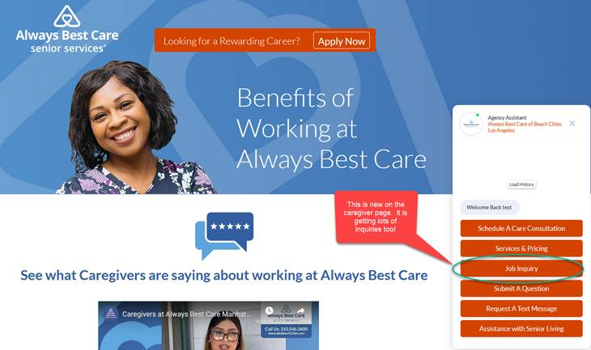

The information on the Chatbot might feel very vague and the reason why is that the goal is to capture the prospects information in order for your recruiter to call, e-mail or text them to set up an interview.  Something we have been working on behind the scenes is a dedicated caregiver testimonial page. Please see below:

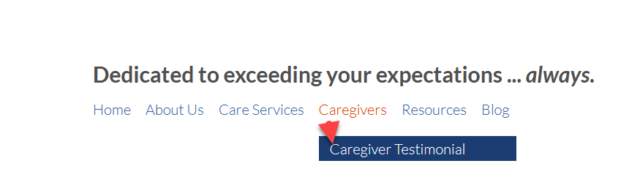

This is going to be customized to each of your offices, so we highly encourage each of you to ask your caregivers for testimonials so we can add them to your page.  Right now yours page will have the national caregiver testimonials rather than localized testimonials. The best part is that it can except both video or text testimonials. I hope you like it.

1. **Caregiver Recruitment Template** – This week we launched a caregiver recruitment template on Emma.  This was an idea I mentioned in our regional meetings a few months back.  This template below has been loaded into everyone’s Emma account, and if you need assistance in creating an Emma campaign, please send us a support ticket with the e-mail addresses you want this campaign to go to.  We would be happy to send this campaign out on your behalf to recruit caregivers from your own personal database.  The plan moving forward is to create a new template layout each quarter so you can have a rotating selection to choose from if you make this an ongoing recruitment campaign.

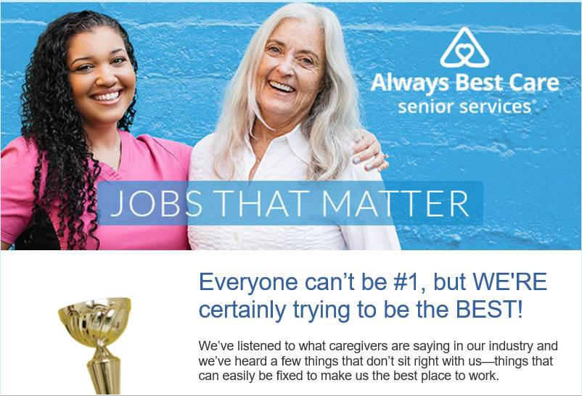

1. **HCAOA Annual Leadership Conference** - <https://www.hcaoa.org/annual-leadership-conference.html>. Interested in participating in this year’s conference, please log into your HCAOA account and sign-up today. By the way, every franchisee has their own unique login for the HCAOA website.  The “Username” is your e-mail address.  If you have not logged in, you will need to create a password.  Just select the “Password Reset” link on the login page to proceed through the steps of creating a new password using your e-mail address.  If you have any issues with logging in, please let me know.
2. **New Marketing Materials –** Although we are making progress on the battle with COVID-19, we still have some time before we hit immunity in this country. With that being said, we expanded upon our materials for the rapid test kits. We now have a consumer facing rack card, a recruiting flyer and a referral partner flyer. All three materials can be found at this link: <http://xbjae.vfyqk.servertrust.com/category-s/127.htm>.
3. **Caregiver Portal Reminder** – In December we had lots of franchisees that chose to use the caregiver portal. What we are waiting for is for you to fill out the caregiver form to populate your portal. Once we get that in hand it takes about a week to transfer that information to your portal. Please take a few minutes to fill that information out and let’s get that portal working for you. If you are interested in implementing the caregiver portal, please contact me directly and I will be happy to get you started.