Marketing Update

- Monthly Marketing Webinar RECORDING – Testimonials and the 2021 Review Manager Updates – In case you missed Friday’s webinar, please click on this link: https://register.gotowebinar.com/recording/7516179440476110093.

- E-mail Signature Review Manager Link – We are trying to make getting testimonials as easy as possible, although the best way is to ask for them. In any case, we created a graphic you can embed on your signature line. The link can go directly to your review manager platform. I attached both the graphic and the document to your specific location. See below on how it should look:

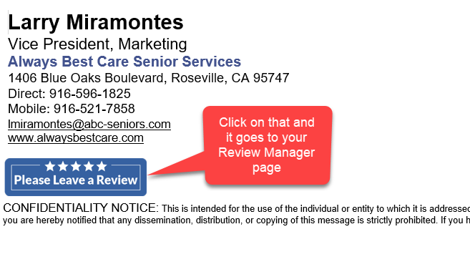

- Chatbot Lead Delivery Change – Technology can never sit still. Last year Family Assets (our chatbot company) rebranded their Virtual Sales Assistant under their new company - Further Technologies. As a result of the rebranding you’ll notice a change to both their logo and domain name of the leads coming to your inbox. Beginning June 14, all newly-branded leads generated by our websites’ VSAs will come from notifications@talkfurther.com instead of notifications@familyassets.com. Everything else will remain the same.

- New Marketing Materials – This month we released three materials to help you with your job recruitment efforts. We will continue to add to this area as we know it is a top priority with your agency. All three materials can be found at this link: http://xbjae.vfyqk.servertrust.com/category-s/127.htm.

- HCAOA Annual Leadership Conference - https://www.hcaoa.org/annual-leadership-conference.html. Interested in participating in this year’s conference, please log into your HCAOA account and sign-up today. By the way, every franchisee has their own unique login for the HCAOA website. The “Username” is your e-mail address. If you have not logged in, you will need to create a password. Just select the “Password Reset” link on the login page to proceed through the steps of creating a new password using your e-mail address. If you have any issues with logging in, please let me know.

- Caregiver Portal Reminder – In December we had lots of franchisees that chose to use the caregiver portal. What we are waiting for is for you to fill out the caregiver form to populate your portal. Once we get that in hand it takes about a week to transfer that information to your portal. Please take a few minutes to fill that information out and let’s get that portal working for you. If you are interested in implementing the caregiver portal, please contact me directly and I will be happy to get you started.

