Marketing Update

- Caring Stars – We are getting to the deadline for the Caring Stars awards and great news you all have an equal chance to becoming a Caring Star. Start by visiting your Caring listing and read your reviews. You must respond online on the Caring review portal to all 1-star and 2-star reviews, and (as needed) get more great reviews to be considered. There is no application for this award — it's determined from the number of reviews published on your Caring.com listing by the deadline (October 15th). The magical number is 10. Within one calendar year, get 10 reviews with three or better stars and you will win a Caring Star recognition. If you get less than three stars you are not out of the competition. All you have to do is respond to those to show you addressed their concerns. They will not count as a review, but it will not hurt you either. Remember, 10 reviews with three stars or better. Good luck everyone!

- Monthly Marketing Webinar – Introducing RAMP (Revenue Accelerator Marketing Program). RAMP will provide Always Best Care franchise locations with a branded, organized sales and marketing program that can be used with local referral partners to educate them on how Always Best Care can help keep seniors safe at home while generating new clients and revenue for Always Best Care franchise locations!
To kick things off, we will be facilitating a webinar that will provide franchise locations, ARs, and National Directors with detailed information about how the program will work, including a preview of upcoming monthly topics for the remainder of the year. Mark your calendar for Friday, September 17th at 10:00am PDT. Click here to register: https://attendee.gotowebinar.com/register/1205649001860620045

- Alzheimer’s Campaign – Some of you may have noticed the home page of Universe with the new Alzheimer’s tile. Click on it to see how your team is performing. We still have plenty of time to get involved.
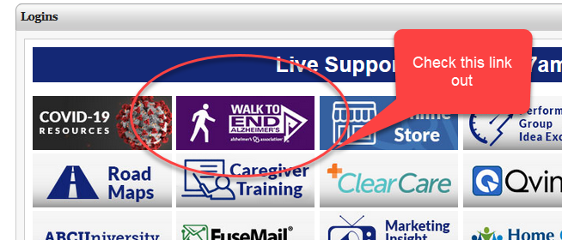

- New Marketing Materials – This month we released new materials to assist your job recruitment efforts and some digital advertising assets. All of these materials can be found at this link: http://xbjae.vfyqk.servertrust.com/category-s/127.htm.

- Caregiver Portal Reminder – In December we had lots of franchisees that chose to use the caregiver portal. What we are waiting for is for you to fill out the caregiver form to populate your portal. Once we get that in hand it takes about a week to transfer that information to your portal. Please take a few minutes to fill that information out and let’s get that portal working for you. If you are interested in implementing the caregiver portal, please contact me directly and I will be happy to get you started.

